

Bachelor of Computer Applications (BCA) Programme

Seminar Report

BCA Sem VI

AY 2023-24

*Topic Title: FPV-DRONES*

*by*

|  |  |
| --- | --- |
| Exam No. | Name of Student |
| 5917 | Goyani Harsh Nareshbhai |

|  |
| --- |
| Seminar Guide by : |
| Prof:- Jaimini Patel |



C E R T I F I C A T E

This is to certify that Mr./Ms. Goyani Harsh Nareshbhai examination number 5917 has satisfactorily completed his/her Seminar

work entitled FPV-DRONES as partial fulfillment of

requirements for BCA Sem VI, during the academic year 2023-24.

|  |  |
| --- | --- |
| Date: 19/03/2024 |  |
| Place: Surat | (Dr. Aditi Bhatt) I/C Principal  SDJ International College, Surat |

**Acknowledgement**

The success and final outcome of this seminar required a lot of guidance and assistance from many people and I am extremely fortunate to have got this all along the completion of my seminar work. Whatever I have done is only due to such guidance and assistance and I would not forget to thank them.

I owe our profound gratitude to our I/c Principal Dr. Aditi Bhatt, Trust representative & IQAC Coordinator Dr. Vaibhav Desai, Head of Department

Dr. Vimal Vaiwala and Seminar guide Jaimini Patel and all other

Assistant professors of SDJ International College, who took keen interest on my Seminar work and guided me all along, till the completion of my seminar work by providing all the necessary information for presenting a good Concept. I am extremely grateful to them for providing such a nice support and guidance though they had busy schedule managing the college affairs.

I am thankful and fortunate enough to get support and guidance from all Teaching staffs of Bachelor of Computer Application Department which helped me in successfully completing my seminar work. Also, I would like to extend my sincere regards to all the non-teaching staff of Bachelor of Computer Application Department for their timely support.

Goyani Harsh N.

5917

*I N D E X*

|  |  |  |
| --- | --- | --- |
| **Sr No** | **Description** | **Page No.** |
| 1 | Introduction to Virtual Reality | 5 |
| 2 | History and improvements of Virtual Reality | 6 |
| 3 | Advantages and Disadvantages of Virtual Reality | 7 |
| 4 | Introduction to FPV-DRONES | 9 |
| 5 | What is FPV? | 10 |
| 6 | How FPV-DRONE works? | 11 |
| 7 | FPV-DRONE key components | 12 |
| 8 | Various types of FPV-Drone | 13 |
| 9 | Photography and Videography | 16 |
| 10 | Safety consideration | 17 |
| 11 | Advantages and disadvantages | 18 |
| 12 | Future Trends | 22 |
| 13 | Conclusion | 23 |
| 14 | References | 24 |

# 1. Introduction to Virtual Reality

## Definition of Virtual Reality:

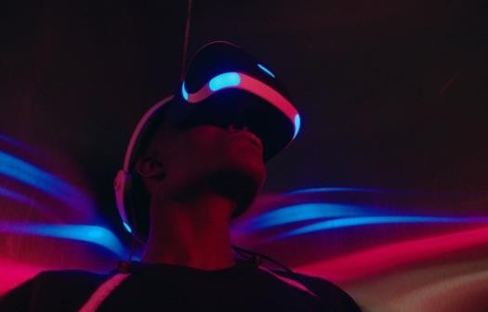Virtual reality is a simulated [3D](https://www.techtarget.com/whatis/definition/3-D-three-dimensions-or-three-dimensional) environment that enables users to explore and interact with a virtual surrounding in a way that approximates reality, as it is perceived through the users' senses. The environment is created with [computer hardware](https://www.techtarget.com/searchnetworking/definition/hardware) and [software,](https://www.techtarget.com/searchapparchitecture/definition/software) although users might also need to wear devices such as helmets or goggles to interact with the environment. The more deeply users can immerse themselves in a VR environment -- and block out their physical surroundings -- the more they are

able to suspend their belief and accept it as real, even if it is fantastical in nature.

## Concept of Virtual Reality

Virtual Reality (VR) is a technology that allows users to interact with a computergenerated environment in a realistic and immersive way, often using specialized hardware such as VR headsets or goggles. The concept of virtual reality revolves around creating a simulated environment that users can perceive and interact with as if they were physically present within it. Here's a breakdown of the key concepts of virtual reality:

## Immersive Experience:

VR aims to immerse users in a digital environment that stimulates their senses, including sight, sound, and sometimes touch, to create a sense of presence and engagement. This immersion is achieved through the use of high-quality graphics, 3D audio, and motion tracking technology.

## Head-mounted Displays (HMDs):

VR headsets, also known as head-mounted displays, are the primary hardware used to experience virtual reality. These devices typically consist of a display screen for each eye, lenses to provide a wide field of view, and sensors for tracking head movements, allowing users to look around and explore the virtual environment.

## Motion Tracking:

VR systems often use motion tracking technology to monitor the user's movements and translate them into corresponding actions within the virtual environment. This allows users to interact with objects, navigate through spaces, and manipulate virtual elements using natural gestures and motions.

## Spatial Audio:

Spatial audio techniques are employed to simulate realistic soundscapes within the virtual environment, creating a sense of depth and directionality that enhances immersion. Users can perceive sounds coming from different directions, distances, and elevations, contributing to the overall sense of presence.

## Interactivity:

Virtual reality environments are designed to be interactive, allowing users to manipulate objects, trigger events, and engage with the virtual world in meaningful ways. This interactivity enhances the



sense of agency and control, empowering users to shape their VR experiences according to their preferences and actions.

## Applications:

Virtual reality finds applications across various fields, including gaming, entertainment, education, training, healthcare, architecture, and engineering. VR technology enables users to explore new worlds, learn new skills, simulate real-world scenarios, and collaborate with others in virtual spaces.

## Presence:

One of the central concepts in virtual reality is the idea of presence, which refers to the feeling of being physically present within the virtual environment. Achieving a sense of presence is crucial for creating immersive VR experiences that captivate users and blur the line between the real and virtual worlds.

## 2.History and improvements of Virtual Reality:

* Virtual reality (VR) has a rich history dating back to the mid-20th century, with significant advancements and improvements over the decades. The concept of VR emerged in the 1950s and 1960s when pioneers like Morton Heilig developed early immersive experiences such as the Sensorama, a mechanical device that stimulated the senses through stereoscopic 3D images, sound, and even scent. In the 1980s and 1990s, the term "virtual reality" gained popularity as computer technology advanced, leading to the creation of more sophisticated VR systems like the Virtuality arcade machines and the Nintendo Virtual Boy.
* However, these early VR systems were bulky, expensive, and often plagued by technical limitations, hindering widespread adoption. It wasn't until the 21st century that VR began to experience a renaissance, fueled by advancements in computing power, graphics rendering, and motion tracking technology. The introduction of consumer-oriented VR headsets like the Oculus Rift, HTC Vive, and PlayStation VR in the mid-2010s marked a turning point, making immersive VR experiences more accessible to the general public.
* 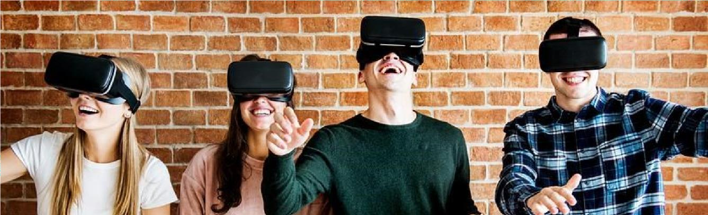 Today, VR continues to evolve rapidly, with ongoing improvements in display resolution, refresh rates, haptic feedback, and hand tracking, enhancing the realism and immersion of virtual environments. From entertainment and gaming to education, healthcare, and beyond, VR has become a versatile and transformative technology with boundless potential for innovation and exploration.



## 3.Advantages and Disadvantages about virtual Reality:

* 1. **Advantages:**

## Immersive Experience:

VR provides an unparalleled level of immersion, allowing users to feel like they're physically present within a digital environment. This immersive experience enhances engagement and captivates users' attention.

## Enhanced Learning:

VR can simulate realistic scenarios and environments, making it a powerful tool for education and training. From medical simulations to architectural walkthroughs, VR enables handson learning experiences that enhance retention and comprehension.

## Entertainment and Gaming:

VR offers new dimensions of entertainment, enabling users to explore virtual worlds, play immersive games, and experience interactive storytelling like never before. VR gaming provides a sense of presence and agency that traditional gaming cannot match.

## Therapeutic Applications:

VR is increasingly used in healthcare for therapeutic purposes, such as treating phobias, PTSD, and chronic pain. VR exposure therapy allows patients to confront their fears in a controlled environment, leading to desensitization and symptom reduction.

## Disadvantages:

1. **Cost and Accessibility:**

VR hardware and software can be expensive, limiting accessibility for some users. High- quality VR experiences require powerful computers or standalone headsets, making them inaccessible to individuals with limited financial resources.

## Health and Safety Concerns:

Prolonged use of VR can cause discomfort and symptoms such as motion sickness, eye strain, and headaches, particularly in users prone to motion sickness. Additionally, VR headsets can pose safety risks if worn improperly or in hazardous environments.



## Isolation and Disconnection:

While VR can create immersive experiences, it can also lead to social isolation and disconnection from the real world. Spending extended periods in virtual environments may detract from face-to-face interactions and real-world experiences.

## Content Limitations:

The availability of high-quality VR content remains somewhat limited compared to traditional media formats. Developing immersive VR experiences requires specialized skills and resources, resulting in a relatively small library of VR content compared to other forms of entertainment.

Despite these challenges, the advantages of VR outweigh the disadvantages for many users and industries, driving continued innovation and exploration of this transformative technology. As VR technology matures and becomes more accessible, its potential to revolutionize how we learn, work, and interact with the world around us will only continue to grow.

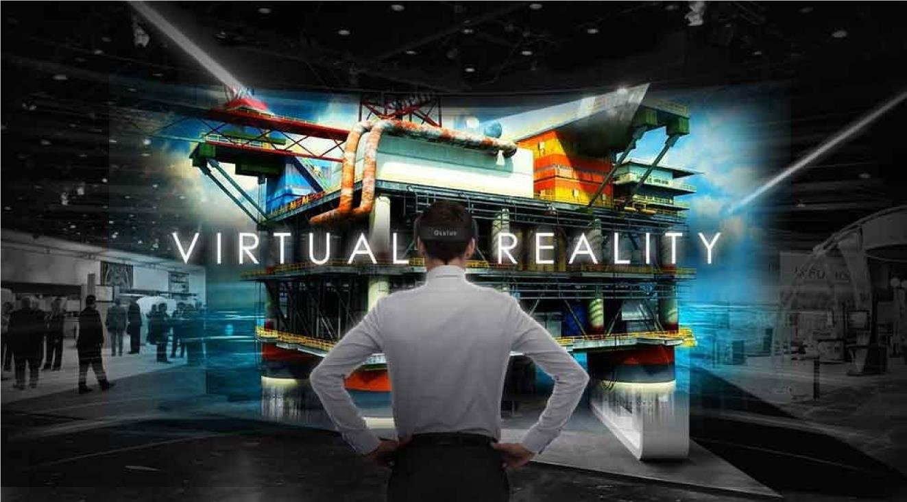



# Introductions about FPV-DRONES

FPV (First Person View) drones have revolutionized the world of aerial exploration and recreation. These drones incorporate a camera mounted on the drone itself, transmitting real- time video footage to a display, typically FPV goggles worn by the pilot. This setup provides an immersive experience, allowing pilots to navigate and explore their surroundings as if they were inside the drone itself.

FPV drones are popular among hobbyists, photographers, and filmmakers for their ability to capture stunning aerial footage and images from unique perspectives. Additionally, FPV racing has emerged as a competitive sport, with pilots racing their drones through intricate courses at high speeds. The agility and maneuverability of FPV drones, coupled with the adrenaline rush of FPV racing, make this hobby both thrilling and rewarding for enthusiasts of all levels.

However, mastering FPV flying requires practice, skill, and a keen understanding of drone mechanics and flight dynamics. Overall, FPV drones offer an exciting way to experience flight and capture breathtaking moments from the sky.

FPV drones have revolutionized the way people experience remote-controlled flight. By integrating live video transmission technology, these drones provide pilots with a real-time view from the perspective of the drone itself. This immersive experience opens up a world of possibilities for aerial exploration, photography, and videography. Whether navigating through tight spaces, exploring scenic landscapes, or racing through obstacle courses, FPV drones offer an adrenaline-pumping adventure for pilots of all skill levels. The compact size and agility of FPV drones make them ideal for capturing dynamic footage in places where traditional camera drones may struggle to reach.

Furthermore, the FPV community continues to innovate with custom builds, new racing formats, and creative uses of FPV technology, ensuring that the excitement surrounding FPV drones will only continue to grow.

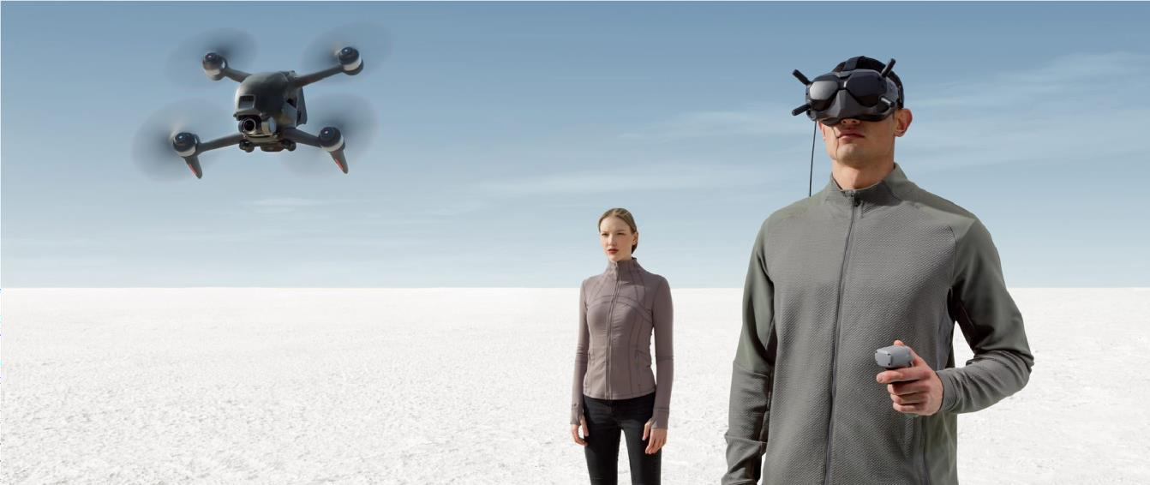



# 5.What is FPV ?

FPV stands for "First Person View." It refers to a method used in remote-controlled vehicles, such as drones, cars, or aircraft, where a live video feed from an onboard camera is transmitted to a display, typically goggles or a monitor, worn or held by the operator. This allows the operator to experience the vehicle's point of view as if they were sitting inside it, hence the term "first person view."

In the context of FPV drones, a small camera is mounted on the drone, capturing realtime footage of the drone's surroundings. This footage is then transmitted wirelessly to FPV goggles worn by the pilot, providing a live video feed. By wearing the goggles, the pilot can see exactly what the drone sees, allowing for precise control and immersive flight experiences.

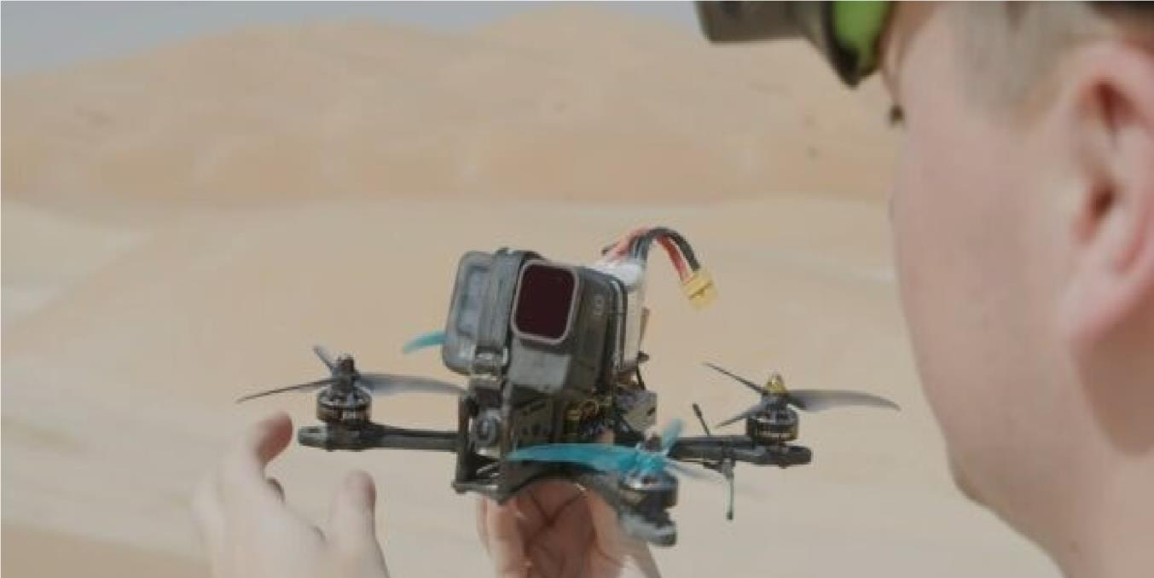

FPV flying offers a unique and thrilling perspective, enabling pilots to navigate through tight spaces, perform aerobatic maneuvers, and explore environments from a bird's-eye view. FPV drones are popular among hobbyists, photographers, filmmakers, and racing enthusiasts for their versatility, agility, and the immersive experience they provide.

FPV technology has evolved significantly over the years, with improvements in camera quality, video transmission systems, and FPV goggles, resulting in better image quality, lower latency, and enhanced user experience. Whether used for aerial photography, videography, exploration, or racing, FPV has become a popular and exciting aspect of the drone hobby.



# 6.How FPV-DRONES works?

FPV (First Person View) drones work by transmitting live video feed from an onboard camera to a display, typically FPV goggles or a monitor, worn or held by the operator.

## Onboard Camera:

FPV drones are equipped with a small, lightweight camera mounted on the drone itself. This camera captures real-time footage of the drone's surroundings, providing a live video feed.

## Video Transmitter:

The video feed from the onboard camera is transmitted wirelessly to the ground. FPV drones use specialized video transmitters (VTX) to send the video signal over radio frequencies, typically in the 5.8GHz band.

### FPV Receiver:

On the ground, the transmitted video signal is received by an FPV receiver, which is typically integrated into FPV goggles or a monitor. The receiver decodes the video signal and displays it on the screen in real-time.

### FPV Goggles/Monitor:

The pilot wears FPV goggles or uses a monitor to view the live video feed from the drone's camera.

FPV goggles are like virtual reality headsets, providing an immersive experience where the pilot sees exactly what the drone sees.

### Radio Control:

In addition to the video transmission, FPV drones are controlled remotely by the pilot using a radio transmitter. The transmitter sends control signals to the drone, instructing it to move, turn, ascend, descend, or perform other maneuvers.

### Flight Controller:

Inside the drone, a flight controller processes the control signals from the radio transmitter and adjusts the drone's motors accordingly to execute the desired maneuvers.

### Power Source:

FPV drones are powered by batteries, typically lithium polymer (LiPo) batteries, which provide the necessary electrical energy to operate the drone's motors, camera, transmitter, and other electronic components.

### Antennas:

Both the drone and the ground station (FPV goggles or monitor) are equipped with antennas to send and receive the video and control signals.



# 7.FPV-DRONES key components.

FPV (First Person View) drones consist of various components working together to enable flight, video transmission, and control. Here are the key components of an FPV drone:

1. **Frame:**

The frame is the structural backbone of the drone, typically made of lightweight materials such as carbon fiber, aluminum, or plastic. It holds all the components together and provides mounting points for motors, propellers, electronics, and other accessories.

## Flight Controller:

The flight controller is the brain of the drone, responsible for stabilizing the aircraft, interpreting control inputs from the pilot, and adjusting motor speeds to maintain stability and control. It also houses sensors such as gyroscopes and accelerometers to measure the drone's orientation and motion.

## Motors:

FPV drones are equipped with brushless electric motors that provide thrust for lift and propulsion. Motors are typically mounted on the drone's arms and connected to the flight controller. They spin propellers to generate airflow and lift the drone off the ground.

## Electronic Speed Controllers (ESCs):

ESCs regulate the speed of the motors by controlling the amount of electrical power supplied to them. They receive commands from the flight controller and adjust the motor speed accordingly. Most FPV drones use one ESC per motor, although some models integrate ESCs into the flight controller.

## Propellers:

Propellers are attached to the motors and spin to generate lift and thrust. FPV drones typically have two clockwise (CW) and two counterclockwise (CCW) rotating propellers to counteract torque and maintain stability during flight. Propellers come in various sizes and shapes, depending on the drone's size and intended use.

## Battery:

The battery provides electrical power to the drone's electronics, including the motors, flight controller, and FPV camera/transmitter. Most FPV drones use lithium polymer (LiPo) batteries due to their high energy density and lightweight properties. Battery capacity and voltage affect flight time and performance.



## FPV Camera:

The FPV camera captures real-time video footage of the drone's surroundings and transmits it to the ground station for the pilot to view. FPV cameras are small, lightweight, and designed for low- latency video transmission. They are typically mounted on the front or top of the drone's frame.

## Video Transmitter (VTX):

The VTX receives video signals from the FPV camera and transmits them wirelessly to the ground station, such as FPV goggles or a monitor. VTXs operate on specific radio frequencies and power levels regulated by local authorities to prevent interference with other wireless devices.

## Receive:

The receiver receives control signals from the radio transmitter operated by the pilot and sends them to the flight controller. It allows the pilot to remotely control the drone's flight maneuvers, such as throttle, pitch, roll, and yaw.

## FPV Goggles/Monitor:

FPV goggles or a monitor display the live video feed from the drone's FPV camera in real-time, allowing the pilot to see what the drone sees. FPV goggles provide an immersive experience, while monitors offer a more traditional viewing experience.

These are the primary components of an FPV drone, although additional accessories such as GPS modules, OSD (On-Screen Display) systems, LED lights, and telemetry systems may also be included depending on the drone's configuration and intended use.

# 8.Various types of FPV-DRONES

### FPV Racing Drones:

These drones are specifically built for high-speed racing competitions. They are lightweight, agile, and optimized for speed and maneuverability. Racing drones typically feature a compact frame, powerful motors, high-performance flight controllers, and low-latency FPV systems for quick response times. They often have a minimalist design to reduce weight and improve aerodynamics.

### Freestyle FPV Drones:

Freestyle drones are designed for performing acrobatic maneuvers and capturing dynamic footage in creative ways. They prioritize agility and responsiveness, allowing pilots to execute flips, rolls, and other aerobatic tricks with precision. Freestyle drones often feature durable frames, high- definition cameras, and adjustable flight characteristics to cater to the pilot's flying style.



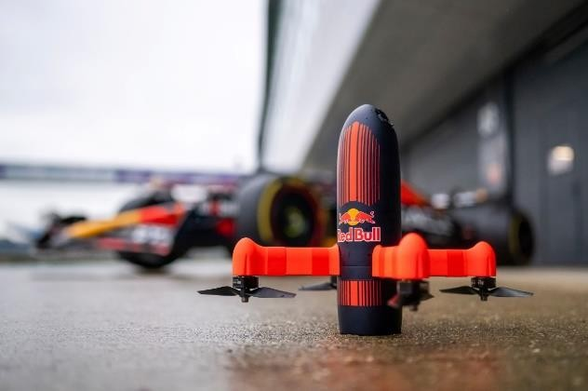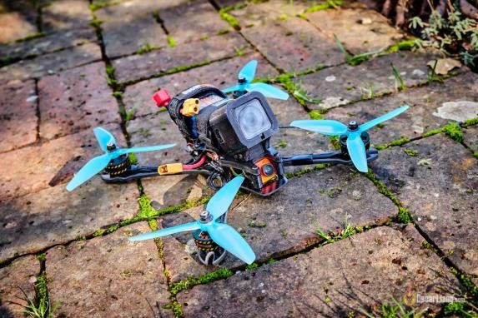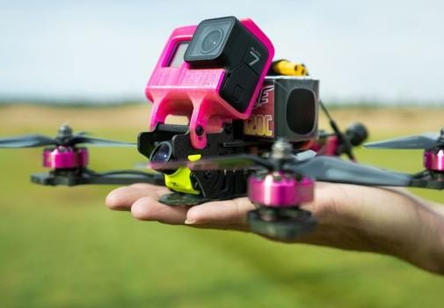

### Cinematic FPV Drones:

Cinematic drones are optimized for capturing cinematic-quality aerial footage and photography. They typically feature stabilized camera gimbals, high-resolution cameras, and advanced video transmission systems to deliver smooth, professional-looking footage. Cinematic drones are often used in filmmaking, photography, and videography projects where high-quality visuals are essential.

### Long-range FPV Drones:

Long-range drones are designed for extended flight distances and exploration over vast areas. They feature high-capacity batteries, efficient power systems, and long-range radio transmitters/receivers to maintain reliable communication and control over longer distances. Long- range drones often incorporate GPS navigation, telemetry systems, and return-to-home functions for added safety and autonomy.

### DIY/Custom FPV Drones:

DIY or custom FPV drones are built by enthusiasts who prefer to assemble their drones from individual components. These drones offer flexibility in design, component selection, and customization, allowing pilots to tailor their drones to their specific preferences and requirements. DIY drones are popular among hobbyists and tinkerers who enjoy building and experimenting with drone technology.

### Professional FPV Drones:

Professional-grade FPV drones are designed for commercial applications such as aerial photography, surveying, mapping, and inspection. They feature high-end components, advanced sensors, and professional-grade cameras to meet the demands of professional users. Professional drones are often equipped with features like obstacle avoidance, thermal imaging, and autonomous flight modes for enhanced safety and efficiency.



* + 1. **Popular brands of FPV-DRONES**

1.DJi

2.Beta FPV

3.EMAX

4.GEPRC

5. Fat Shark

6.I-Flight

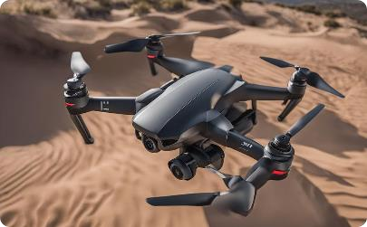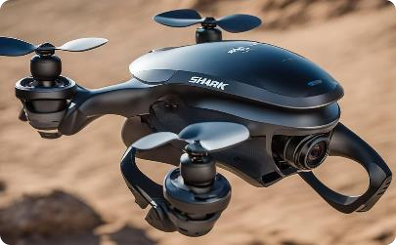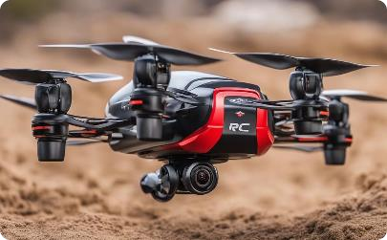

## FPV-DRONE Racing

FPV (First Person View) drone racing is an exhilarating and fast-paced sport that combines the thrill of high-speed flying with the excitement of competition. Pilots race small, agile drones equipped with FPV cameras through obstacle-filled courses at speeds that can exceed 100 miles per hour.

The immersive first-person view provided by FPV goggles allows pilots to navigate through tight spaces, perform aerobatic maneuvers, and race against opponents in real-time.

Racing courses are designed to test pilots' flying skills and reflexes, featuring a variety of obstacles such as gates, flags, pylons, and obstacles arranged in challenging configurations. Races can take various formats, including time trials, heats, elimination rounds, and multi-round tournaments, with pilots competing to complete the course in the fastest time.

FPV drone racing has a vibrant community of enthusiasts, pilots, and organizers who participate in local, national, and international events held at dedicated racing tracks, parks, or indoor venues. With its growing popularity and dedicated community, FPV drone racing continues to push the boundaries of drone technology and showcase the skills of pilots around the globe.



# 9.FPV-DRONE photography and videography

Cinematic FPV is high-speed drone cinematography to the exciting world of FPV (First Person View) drone services, an innovative and immersive approach to aerial photography and videography that can significantly enhance your marketing and promotional efforts. Unlike traditional drone services, FPV drones capture dynamic, high-speed footage that takes viewers on a thrilling visual journey through your facilities, products, or events.

With their exceptional maneuverability and ability to navigate tight spaces, FPV drones offer a unique perspective that sets your brand apart from the competition. These captivating videos can be used in advertising campaigns, social media content, product launches, and virtual tours, generating increased interest and customer engagement.

Beyond marketing, FPV drone services can also improve operational efficiency through rapid inspections and monitoring, providing valuable insights for businesses across various industries, such as construction, real estate, and event management. Embrace the power of FPV drone services and elevate your business to new heights with this cutting-edge technology.

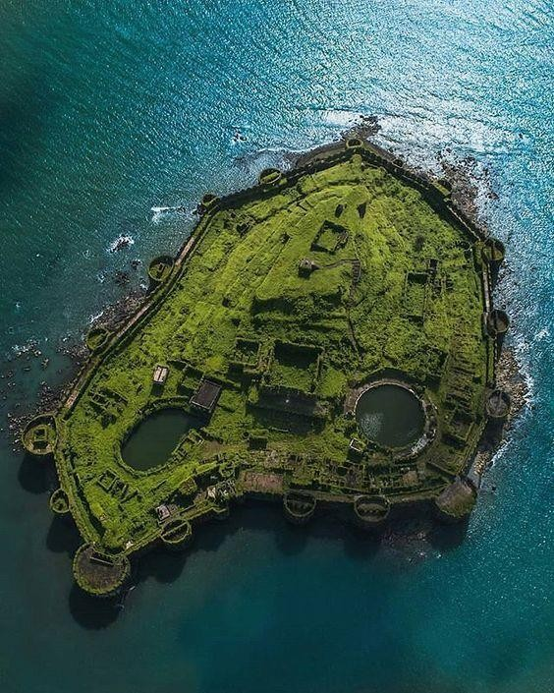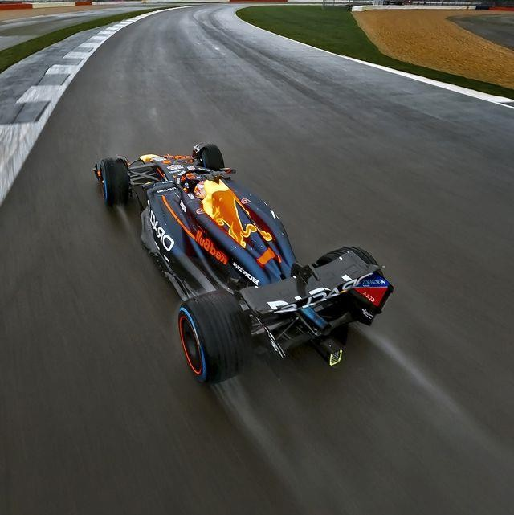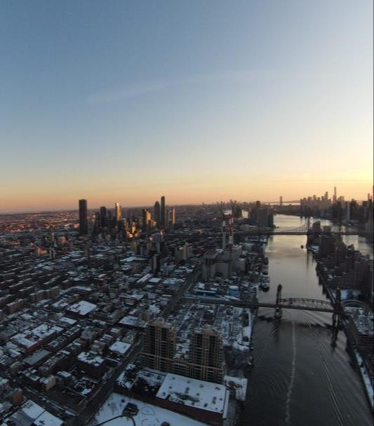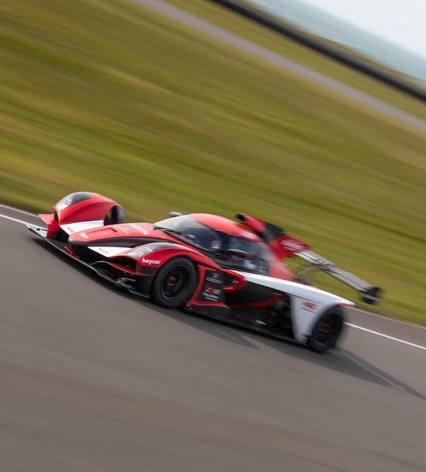



# 10.Safety consideration for flying FPV-DRONES

## General guidelines

When flying drones that have larger-than-5-inch propellers or are powered by 3S LiPo or more powerful batteries, safety glasses must be worn and safety gloves must be worn when handling the drone. IRL has provided safety glasses and safety gloves at the entrance of the flying arena. Please restore the safety equipment after usage.

Drones that weigh more than 250g or have larger-than-5-inch propellers must only be armed inside the netted area.

When flying a vehicle tethered to the ground using a safety cable provided by IRL, no more than 3 people can be inside the netting arena simultaneously. When flying a free vehicle, no one can be inside the netting arena; everyone should be outside the netting arena before the vehicle can take off.

When using a small carbon-fiber or metal-prop vehicles, all operators must be outside the netting area and wear safety glasses.

## During operation:

* Use extra caution when performing a maiden flight/experiment
* Drones must not be flown closer than 2m to any Vicon camera.
* When operating your robots inside IRL, be alert and clear. You should:
* stand at least five feet away from vehicle, behind the netting
* everyone must be mentally alert
* before making any move, communicate with others loud and deliberate
* Before arming, the pilot must shout it out: “Arming!”
* Before taking off, the pilot must shout it out: “Taking off”
* To land the vehicle, the pilot must shout it out: “Landing”
* Only after disarming a landed vehicle, the pilot must shout it out: “Disarmed”
* Disconnect the main battery to your vehicle as soon as you can after the vehicle is landed.

## Crashes:

Use extra caution to recover a crash

When retrieving a crashed UAV or other possibly damaged equipment or autonomous vehicle, safety glasses and safety gloves must be worn and proper shoes and attire must be worn. If uncertain of the safety of the operation to be undertaken, you must notify the IRL Lab Manager or other senior CSL official and obtain permission before proceeding.

When retrieving a landed carbon-fiber or metal-prop vehicle inside the netting area, protection gloves must be used. In general, use extra caution for dealing with carbon-fiber or metal-prop vehicles.

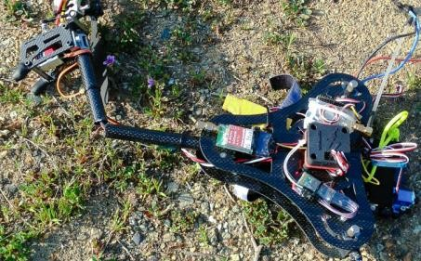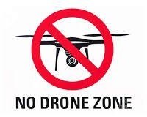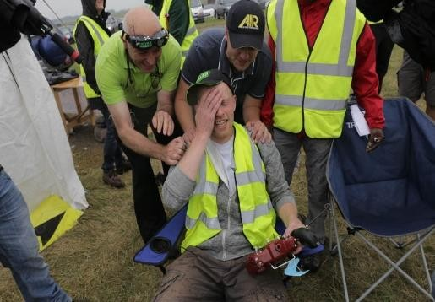



# 11.Advantages and Disadvantages of using Fpv-Drones

## Advantages

1. **MAINTAINING SAFE ENVIRONMENT –**

UAVs are utilized in numerous occurrences due to their advancement in safety. With their remote control abilities, Drones monitor locations, communicate possible hazards, and notify threatening conditions. such as oil and gas refineries,pipelines and flare stacks. Not only this, Drone Technology is employed in the military during high-risk periods as well. Their features allow them to obtain real-time data to create and preserve a safe environment.

## COST SAVING TECHNOLOGY –

As drone’s applicability becomes more extensive, their prices also drive towards being more pocket-friendly. People now acquire Drones not just for their industrial practices but also to fulfill their tech-savvy gadget’s passion. UAVs are no longer equipped only for the military, law authorities, or the elite. Since UAVs take over several workforces, vehicles, and operation activities in commercial uses, many costs are preserved. For example, a Drone is more economical to buy, sustain, and fuel than airplanes for inspections. In addition you don’t need to hire a ladder, aerial lifts, and other heavy equipment.

## AERIAL PHOTOGRAPHY-

With their high-resolution cameras furnished with top-notch sensors, UAVs can take excellent Aerial Photographs, aerial videos and accumulate large volumes of accurate data. The data obtained is transformed into detailed 3D Maps and 3D Models for a complete analysis. 3D Mapping is particularly relevant to disclose cracks, damages, or other hazardous elements in disaster areas. Drones, when paired along with high-resolution images or 4K video abilities, is well-known for live streaming significant events such as entertainment, personal, political, and global affairs.

## PRECISION –

UAVs appropriate GPS (the Global Positioning System) in their software, which is why they can be programmed and guided precisely to specific locations. For example, in Precision Agriculture, a Drone Aircraft is employed to perform many farming obligations like pesticide spraying, identification of weeds, monitoring crop health, crop damage, crop assessment, field soil analysis, Irrigation Monitoring etc. This feature of precision through the GPS conserves time and expenses for farmers.

## EASY CONTROLLABLE OR DEPLOYABLE –

The regular advancement in drone-control technology allows operators to quickly deploy and operate drones even with a relatively minimal technical background. With an extensive range of low- cost drones available for several purposes, drones are open to a broad spectrum of operators. Unmanned aerial vehicles (UAVs) have a more comprehensive range of movement, fly lower in all directions, and can navigate effortlessly when contrasted to a crewed aircraft.



## SECURITY –

Another advantage that weighs out the pros and cons of a drone is the security centered around them. With relevant permissions and licenses, drone operators can utilize an Unmanned Aircraft System (UAS) to render safety and surveillance to private organizations, potential venues, and other expenses. Drones can also accumulate reliable information from natural catastrophes to support safety and recovery efforts.

## MINIMIZES OBVIOUS DANGER AND HEALTH RISKS –

With the support of a Drone, numerous dangers like elevation, wind, weather, and radiation that were earlier suffered by crew members have been replaced with more viable and safer alternatives. Drones facilitate straightforward and secure inspections of towering and complicated constructions like oil and gas refineries, flare stacks, and pipelines.

## IN-DEPTH AND DETAIL DATA INPLACE –

Many drone models are launched into the market with obstacle avoidance capacities. They can operate quite close to constructions, and this encourages them to seize precise data. They capture high-resolution images or 4K videos that explicitly reveal cracks, damages, displaced wires, and additional defects that we cannot detect through our naked eye. UAVs allow obtaining complete data without endangering inspection crew members of the company.

## FLEXIBILITY FOR QUICK INSPECTIONS –

Since Drones come with varied specifications, several can provide high or low altitude Inspections. The versatility of these characteristics empowers clients to customize the tools with ease for their projects. Drones are suitable for both regular and emergency scenarios, the Construction Industry abides by these advantages, especially building developers for Rooftop Inspections. Drones can carry out multiple roles, such as capturing high-quality photos, videos, thermal images, etc. This data is then transmitted and processed immediately, as opposed to the time-consuming conventional method.

## REACH HAZARDOUS AREA –

UAVs make obtaining efficient data from hard-to-reach locations a cakewalk for industry professionals. It is the most suitable alternative to overcome limitations of traditional methods regarding worker’s safety, especially in hazardous situations like radiation monitoring, inspecting high-voltage lines. Drones also allow a more cost-effective approach toward inspections of these locations.



## Disadvantages

**1. PRIVACY** –

While drone’s benefits are endless, drone technology has several downsides to it. UAVs can quickly fall prey to manipulation and trespass a group or individual’s privacy. Though many desire to utilize drones for retaining safety, it could violate numerous individual liberties in the name of public security.

## 2. LEGISLATIVE UNCERTAINTY –

The use of Unmanned Aircraft Systems (UAS) has become widespread; however, the law is still developing, considering it is a novel technology in the industry. Specific practices installed for tiny drones also apply to commercial and recreational applications but are still vague in several dimensions. Rules for the regulation of drone movement and property protection from aerial trespassing are still in the making; thus, UAV technology functions in a judicial gray zone. There are numerous frictions between governmental regulations and any state or city laws to manage airspace property rights, because of which drone operators may violate rules they didn’t know about.

## 3. SAFETY –

Safety is a fundamental element to prioritize when operating drone technology. UAVs outfitted with high-quality sensors recognize possible collisions and safely engineer their way around them, making them a significant trait. These drone capacities must resemble those of the manned aircraft navigators. It is commendable to hire professional drone service providers who can operate an aerial drone without crashing it. Drones operated in heavily-populated regions have an amplified risk of ground impact or damage, mainly due to system malfunction or hacking.

## 4. SOFTWARE ISSUES OR MALFUNCTION –

There have previously been many drones that have fired weapons to commoners, generating a significant amount of casualties, injuries, and damages due to malfunctions or software blunders. Drone mishaps strike other military personnel’s safety as well. Drones are still in the process of improvement to limit accidents or hazards that can affect the health and safety of human lives.

## 5. VULNERABLE TO WILD ANIMALS –

Drones are susceptible to wild animal attacks and are sometimes also dangerous to nature. It is possible that when a drone operator is flying in a domain with a considerable number of wild animals, they crash against a tree or possibly conflict with a vulnerable animal. Large flying birds like eagles are regularly attacking and even capturing drones operating in their space to obtain crucial data.

## 6. SPYIN-

Many offenders employ drones as a strategy to target their victims and to maintain a track on them. The blatant propeller noises are no longer a concern and are unnoticeable, enabling criminals to invade someone’s privacy. Many drones furnished with thermal and night sensors identify life



signs and efficiently target those currently of interest by the spy. Since UAVs can seize accurate data, they can register regular habits and recognize suspicious activities without permission.

## 7. EASY TO HACK –

One substantial downside to drone technology’s growth is its vulnerability. Hackers can quickly attack a drone’s central control system and become the drone’s original controller. The primary control system includes significant knowledge crucial for hackers to evade without the initial operator’s awareness. Hackers can acquire private information, corrupt or damage the files, and leak data to unauthorized third parties.

## 8. WEATHER DEPENDENT –

Drones are more vulnerable to weather conditions when contrasted to traditional aircraft. For example, if the climatic conditions are unfavorable, the UAV will not maneuver appropriately or gather reliable data or imagery. However, there are drones available that are more stable and can withstand gusts of wind successfully.

### 9. KNOWLEDGE AND SKILL –

As discussed earlier, if one necessitates seizing accurate, high-quality data, they need to possess the demanded skillset. This specification would indicate that an average farmer would require comprehensive training or a third party drone service provider to capture, process, and analyze farming data. With expanding operators in the industry, drone costs and its accompanying resource expenses will gradually reduce.

## 10. DATA TRANSFER SPEED IS SLOW –

One of the cons in expanding drone technology in precision agriculture is its data transmission speed, which some suppose could be a week. If the time necessitated for data delivery results in a farmers’ unproductivity and damage to fertilizers, crops, or pesticides, the operation of the drone would be a waste in the end. Thus, if data transfer speed is slow, suffering and damage can occur in that period, following all efforts going to waste.



# 12.Future of FPV-DRONES

First one would be increasing the headset FOV (field of view) drastically to the level of Pimax VR headset for example. I own Pimax, and after not having used it for a month or so due to all my time having been spent on FPV, switching from DJI headset to Pimax just blew my mind yesterday. Pimax FOV feels closer to real life FOV than to DJI headset, just to give you an approximate feel for what it's like.

Next step, stealthy but incredibly important one, would be matching the fov and distortion profile of the camera to that of the headset, the way VR games do it, to make you feel like you are really there. Those two things alone are within reach at a cost increase that shouldn't be too prohibitive to most current users.

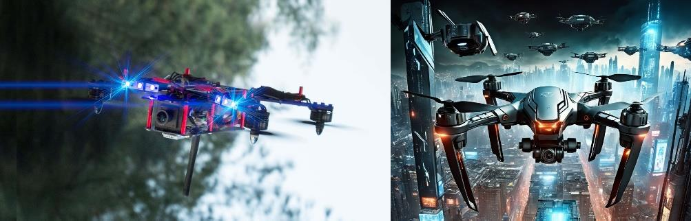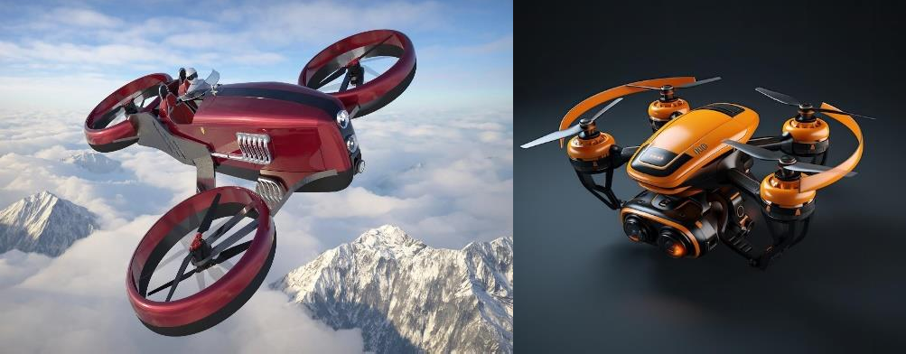

Following that, having proper stereo implementation is where the real magic would be. While stereo is historically limited by bitrate and DIY attempts at this produced poor results due to halving of bitrate, it's possible to fix this issue in software by encoding only the difference between frames for the second eye, thus increasing the bandwidth requirement by mere 5-10% rather than it being double. This is the same tech that reconstructs the next frame of video from the data in previous frame, enabled by their similarity. Drone would need two cameras of course, but the difference in experience would be huge and absolutely worth it.

Next thing would be to have camera gimbals controlled by head movement. As simple as adding a gyro to headset and having multi axis gimbal like that of a mavic. Delay in rotation can be solved by using asynchronous reprojection tech from PC VR space. I'm pretty sure I could fly manual with this kind of setup alone, but if needed, a reticle overlay could be placed at a user defined angle to serve as a reference point.

Future of this tech is going to absolutely mind blowing and it can't happen soon enough, especially because it's all possible right now with current tech, and is mostly about writing code and product development**.**



# 13.Conclusion

In conclusion, FPV (First Person View) drones represent a remarkable fusion of technology, creativity, and adventure. These drones have revolutionized the way we experience flight, providing pilots with an immersive and exhilarating perspective from the skies. Whether it's racing through obstacle courses at breakneck speeds, capturing breathtaking aerial footage from unique vantage points, or exploring new environments with a sense of freedom and wonder, FPV drones offer endless possibilities for exploration and excitement.

The FPV community is a testament to the passion and ingenuity of enthusiasts, pilots, and creators who push the boundaries of drone technology and innovation. As FPV technology continues to evolve and become more accessible, the future holds even greater potential for FPV drones to inspire creativity, foster community, and unlock new opportunities for adventure and discovery. Whether you're a seasoned pilot or a newcomer to the hobby, FPV drones offer a thrilling and immersive way to experience the world from a whole new perspective.

In addition to their recreational and competitive appeal, FPV drones have also found practical applications across various industries. From aerial photography and cinematography to search and rescue operations, agriculture, infrastructure inspection, and more, FPV drones offer versatile solutions that enhance efficiency, safety, and productivity.

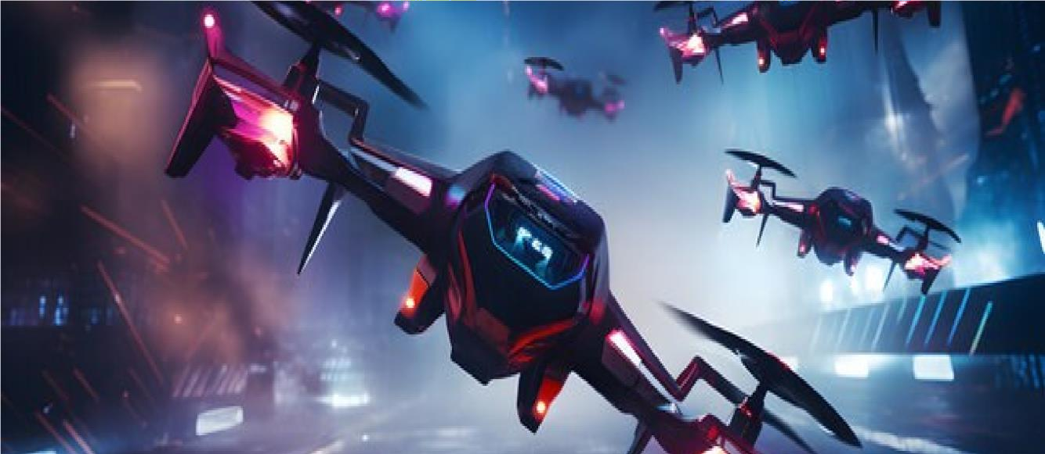

Their ability to access hard-to-reach areas and capture high-resolution imagery makes them valuable tools in fields such as surveying, mapping, and environmental monitoring. Furthermore, the continuous advancements in FPV technology, including improvements in camera quality, video transmission systems, and flight performance, ensure that FPV drones remain at the forefront of innovation and discovery.

As society continues to embrace the potential of unmanned aerial vehicles, FPV drones are poised to play an increasingly integral role in shaping the future of aerial exploration, entertainment, and industry.



# 14.References

* + - https://fpvfc.org/getting-started-with-fpv
    - https://[www.dji.com/global](http://www.dji.com/global)
    - https://insidefpv.com/
    - https://[www.quadkart.in/](http://www.quadkart.in/)
    - https://tujorc.com/
    - <https://en.wikipedia.org/wiki/First-person_view_(radio_control)>
    - [vhttps://www.youtube.com/@man.fromearth](https://www.youtube.com/%40man.fromearth)

**Thank You…!**